Responsive Web Design

# Media query, hide and show elements

## Exercise 1

Use the default folder structure and insert the following elements:

<header> (100 pixels high)

<img> (300 x 100 pixels - use i.e. dummyimage.com)

<nav> with <ul> and 3 x <li> <a> that may resemble this:

The links does not have to be styled like the screenshot above.

Let the background color of the header change in these intervals:

0-767 pixels (extra small device)

768-991 pixels (small device)

992-1200 pixels (medium device)

> 1200 pixels (large device)

## Exercise 2

When the viewport is medium or large, the <nav> with the ul shall be displayed.

When the viewport is small or extra small an <img> (200 x 100 pixels) shal be displayed instead - still positioned right.

## Exercise 3

When the viewport is extra small the logo shall be changed to an <img> with the dimensions 100 x 100 pixels and the right positioned <img> shall still have the dimensions 200 x 100 pixels.

**Hints**:

|  |
| --- |
| Yes - media queries or media rules (@media) is the good friend in these exercises. This is an example of how to use it.    When you develop mobile first you will have this structure:  [CSS for smallest devices - no @media]  @media screen and (min-width: 768px) { … }  @media screen and (min-width: 992px) { … }  @media screen and (min-width: 1200px) { … } |
| If the parent element is 100 pixels high, then the content may be vertical aligned in the middle by adding lineheight: 100px. |
| Background color is set with: |
| You may use placeholder images from i.e. [dummyimage.com](http://dummyimage.com) like this:    or with CSS as background image: |
| To hide or show an element use display: none (hidden) or display: block (if you want to display the element as block-level element). |

# Flexible images

## Exercise 1

Use the default folder structure and insert the following elements:

A <section> or <main> element to hold the images.

8 <div> elements with the height of 400 pixels. Give them a background color to seperate them from the body background color.

The 8 <div> elements shall be ordered in a grid corresponding to these intervals:

0-767 pixels (extra small): one <div> per row

768-1200 pixels (small and medium): two <div> elements per row

> 1200 pixels (large): four <div> elements per row

Make some space between and outside the <div> elements.

## Exercise 2

Insert a placeholder image in each of the <div> elements. The dimensions of the image shall be 600 x 600 pixels. You may use [lorempixel.com](http://lorempixel.com) in order to retrieve different images (they have different categories of images).

The images shall fit in the <div> element and scale according to its parent element (the <div>).

## Exercise 3

Insert a <p> element with some text (i.e. “Great product”) in each of the <div> elements. It shall be positioned in the bottom of the <div> above the image.

**Hints**:

|  |
| --- |
| Flexible images is obtained with the general CSS rule: |
| To distribute the <div> elements evenly on a row, you may want to divide 100% by the number of <div> elements to give them the correct width. |
| To position a child element within a parent element, the parent element shall have position set to relative and the child element can then be positioned absolute at the bottom with the property bottom: 0 - or at the top with the property top: 0. |

# Products page exercise

In this exercise you shall develop a responsive version of a products page that supports these intervals:

0-767 pixels (extra small device)

768-991 pixels (small device)

992-1200 pixels (medium device)

> 1200 pixels (large device)

You shall develop mobile first and the following screen shots are only thought as inspiration. You may choose the colors, dimensions, fonts, font sizes, images as you like. The final version is expected to adhere to the requirements below.

A demo of a possible solution is available at:

<https://www.youtube.com/watch?v=VlEoVc6I3K8>

You may try out Font Awesome (<https://fortawesome.github.io/Font-Awesome/>) for use of icons (burger menu, plus and minus icons, etc.). Font Awesome is used in the demo.

The font used in the demo is “Open Sans” from Google in weight 400 and 700. If you like to try out this font or other fonts, read more at <https://www.google.com/fonts#>.

**Header (extra small and small)**

The header area shall hold a logo, a “burger-menu” link and a button to the categories. The link or button is not expected to be operational (with JavaScript).

**Header (medium and large)**

The header area shall hold a logo, three links and two buttons for authentication. The active menu link shall stand out from the other links.

**Categories (extra small and small)**

When the categories button has been clicked, the categories are shown below the header area. It is not expected that it is possible to expand and collapse sections (+ and - buttons). It is though possible to mimic that the categories button has been clicked. You do that by setting the aside’s display property to “block” or “none”. This should be possible without breaking the layout on any resolution interval.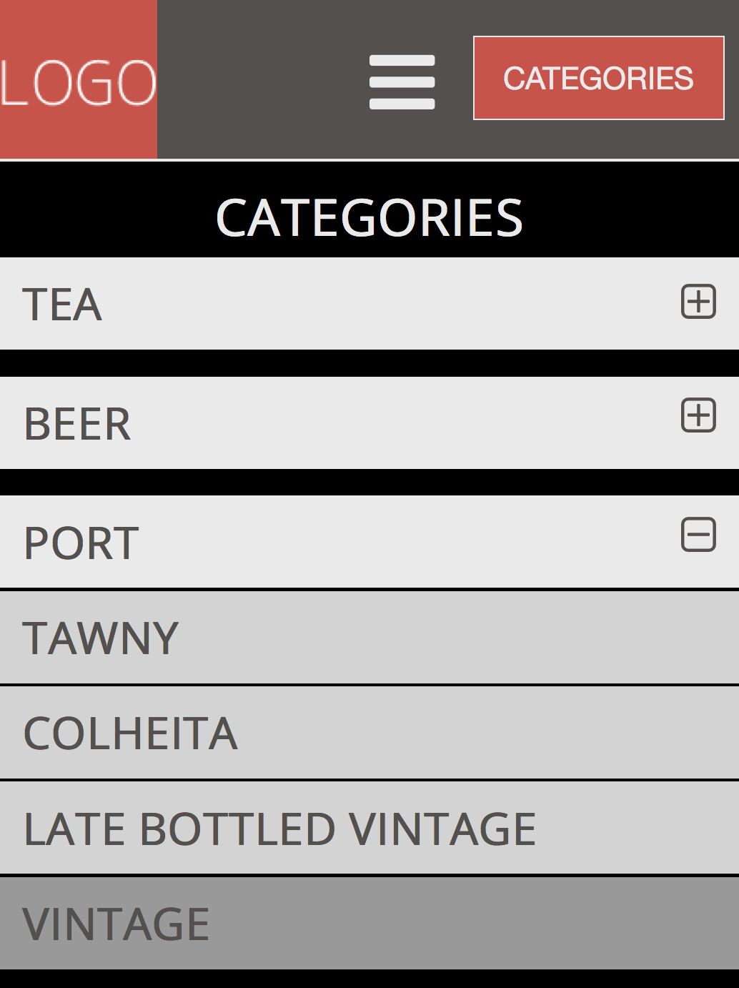

**Categories (medium and large)**

The categories are shown in the left area.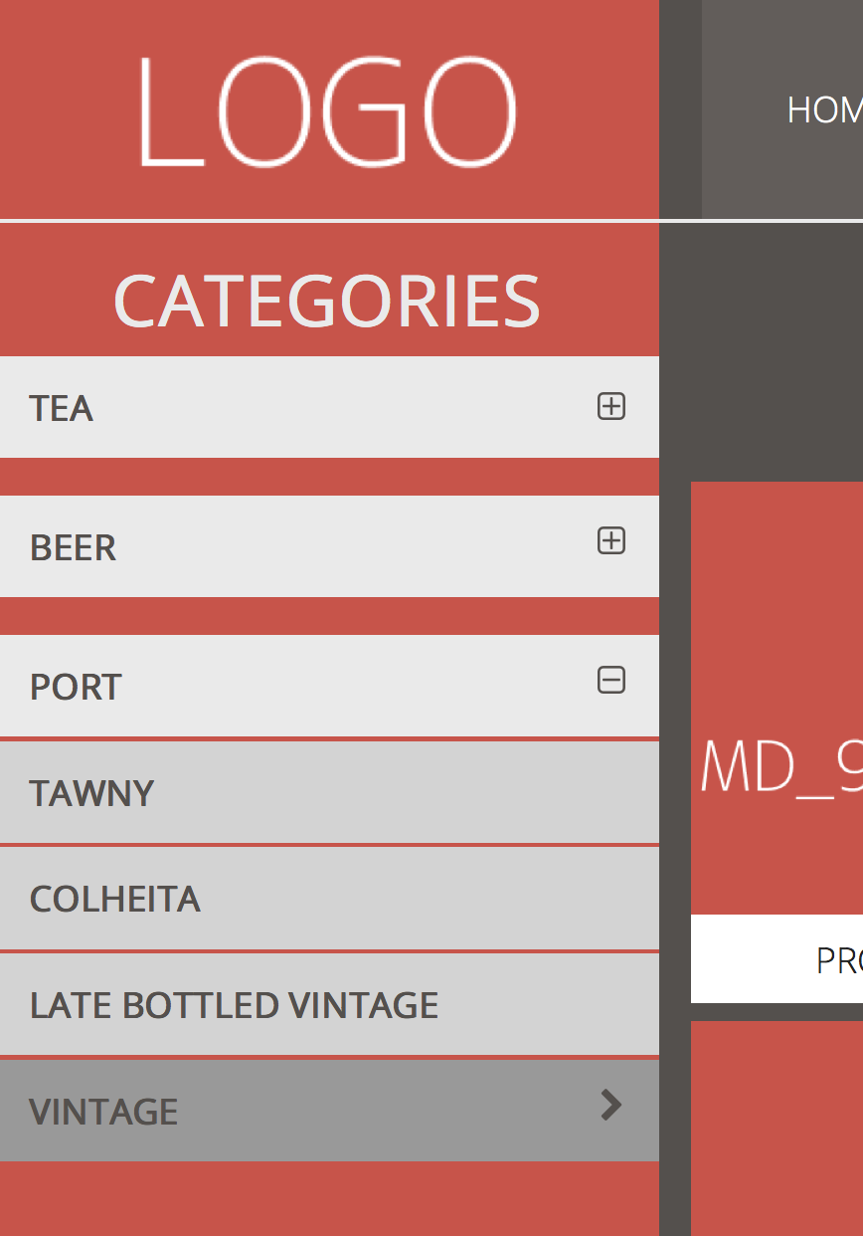

|  |  |
| --- | --- |
| **Products (extra small 0-480 pixels)**  The products are shown with one product for each row. | **Products (extra small 480-767 pixels)**  The products are shown with two products for each row. |

**Products (small 768-991 pixels)**

The products are shown with two products on each row.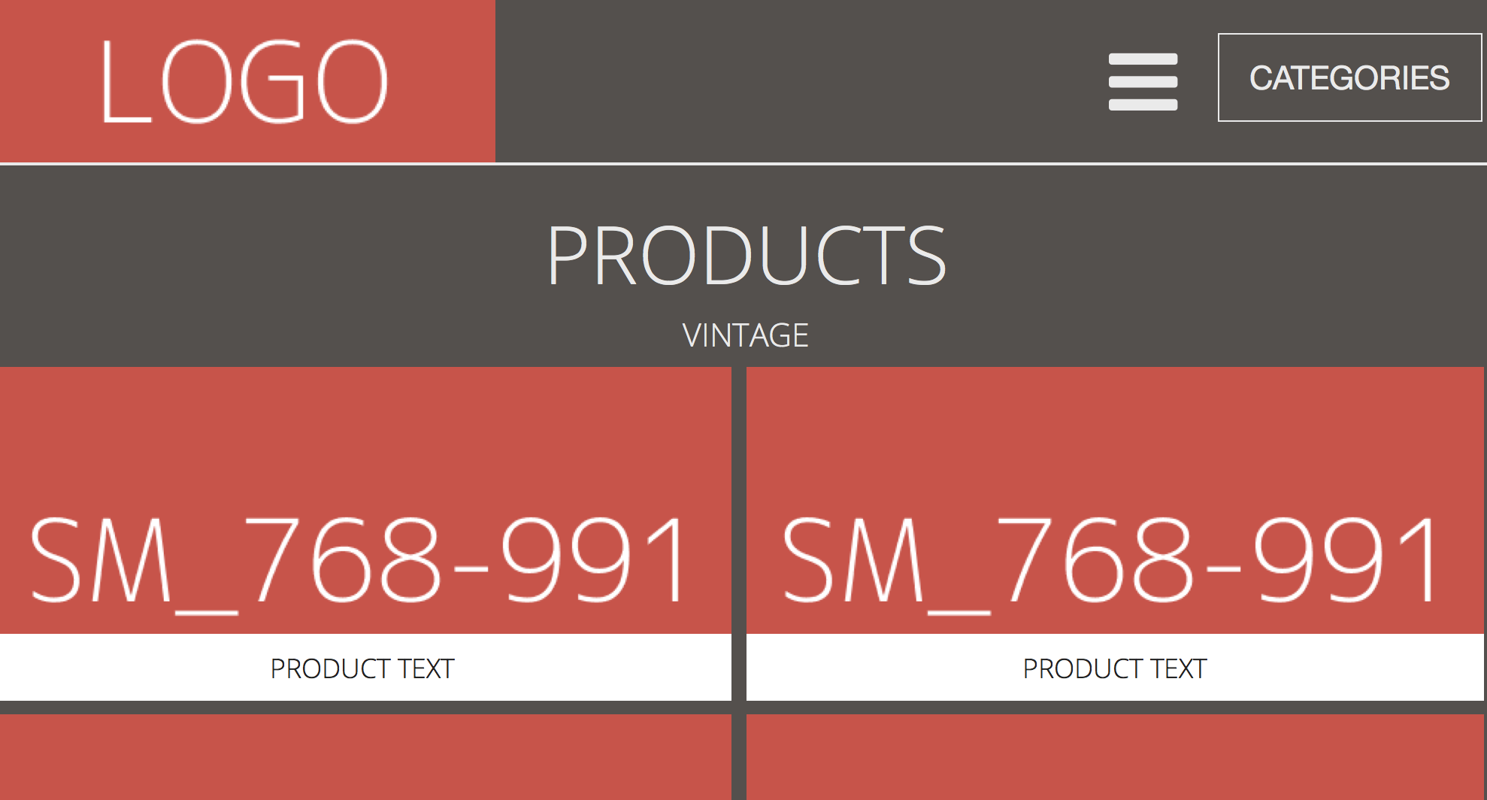

|  |  |
| --- | --- |
| **Products (medium)**  The products are shown with three products for each row. | **Products (large)**  The products are shown with four products for each row. |

**Centering content (large)**

On large displays the whole page is centered with white space to the left and the right.